**FOODIFY**

**A Recipe Recommendation App**

**Group Members:**

**Hiyaa Shah 16010121177**

**Vatsal Soni 16010121197**

**Raghav Srivastava 16010121198**

**Project Mentor:**

Prof. Zaheed Shaikh

**Abstract:**

The Recipe Recommendation System is a comprehensive platform that combines the convenience of real-time recipe search with the precision of an in-app health tracker. By assessing user health metrics such as BMI, calorie intake, and overall health type, the system gains valuable insights into each user's unique dietary needs and goals. These insights, combined with analysis of the user's past recipe preferences, enable the system to generate tailored recipe recommendations that align with individual health objectives.

Furthermore, the system actively addresses the issue of food waste by suggesting recipes that make the most of ingredients already available to the user, thereby promoting sustainable cooking practices. Whether users are looking to manage their weight, improve their overall health, or adhere to specific dietary restrictions, the system provides recipe options that cater to their preferences and nutritional requirements.

To enhance user engagement and satisfaction, the system offers a range of interactive features such as cooking tutorials, ingredient substitution suggestions, and community forums. By fostering a sense of community and providing valuable resources for culinary exploration, the system encourages users to not only discover new recipes but also to develop their cooking skills and knowledge.

**Table of Content:**

|  |  |  |
| --- | --- | --- |
| **Sr.no** | **Title** | **Page No.** |
| 1 | Chapter 1: Introduction | 1 |
| 2 | Chapter 2: Literature Survey | 5 |
| 3 | Chapter 3: Project Design | 9 |
| 4 | Chapter 4: Implementation and Experimentation | 17 |
| 5 | Chapter 5: Conclusion and Future work | 27 |
| 6 | Bibliography | 30 |
| 7 | Acknowledgements | 30 |

**List of Figures:**

1.1 Gantt Chart

2.1 Class Diagram

2.2 Sequence Diagram

2.3 Use Case Diagram

3.1, 3.2, 3.3, 3.4, 3.5, 3.6, 3.7, 3.8, 3.9, 3.10, 3.11, 3.12 Testing

**List of Tables:**

1.1 Literature Survey

1.2 Software Project Management Table

1.3 Timeline Chart

**Nomenclatures:**

ML - Machine Learning

RAM - Random Access Memory

OS - Operating System

AI - Artificial Intelligence

BMI - Body Mass Index

UML - Unified Modeling Language

KDD- Knowledge Discovery in Database

**Chapter 1**

**Introduction**

*This chapter provides an introduction to the Recipe Recommendation System, elucidating its aims, scope, and significance in utilizing modern technology for culinary exploration. It delves into the vital role of recipe recommendations in enhancing culinary experiences and fostering healthier eating habits. Moreover, it sheds light on the specific focus areas of the system, including diverse cuisines, dietary preferences, and nutritional balance. The chapter also outlines the fundamental components comprising the recommendation system, offering insights into its architecture and functionality.*

The food recipe recommendation mobile application revolutionizes meal planning by leveraging machine learning algorithms to provide personalized recipe suggestions based on user-provided ingredients. With the ability to analyze user preferences and dietary needs, the app offers a streamlined solution for users seeking culinary inspiration while optimizing ingredient usage. The food recipe recommendation mobile application integrates a BMI (Body Mass Index) calculator alongside its machine learning-driven recipe recommendation system. By combining these features, the app offers a comprehensive solution for users striving to maintain a healthy lifestyle through informed meal planning and nutritional awareness.

The significance of this project lies in its ability to cater to individual preferences and dietary restrictions, offering tailored recipe recommendations that align with users' available ingredients. By encouraging healthy eating habits and minimizing food waste through efficient ingredient utilization, the application not only enhances user experience but also contributes to sustainability efforts.

In response to the growing need for individualized nutrition and wellness solutions, a mobile application for food recipe recommendations was created with an integrated BMI calculator. The initiative intends to address health issues and encourage sustainable eating habits by utilizing advancements in AI and machine learning to deliver consumers personalized recipe recommendations.

**1.1 Background/Motivation**

The motivation behind this project is to address the common challenge individuals face in creating meals with acquired ingredients, especially when health-conscious living is a priority. By developing a Recipe Recommendation System and Health Tracker, the project aims to empower users to make the most of their pantry by suggesting recipes based on available ingredients and promoting a holistic approach to well-being through personalized diet recommendations and BMI tracking. The goal is to simplify the cooking process and enhance overall health awareness, catering to both culinary creativity and health-conscious living.

**1.2 Problem Statement**

* The goal of this project is to design and implement a reliable and efficient Recipe Recommendation System.
* Search for recipe in real time
* Develop a real-time Recipe Recommendation System integrating an in-app health tracker to assess user's health metrics (BMI, calorie intake, overall health type), and suggest recipes based on the user's historical preferences.

**1.3 Scope**

The project's scope is comprehensive, covering ingredient diversity, a wide range of recipes, a user-friendly Flutter-based interface, inclusive health tracking, educational content on nutrition, scalability for future updates, potential external integrations, adaptability to cultural preferences, and cross-platform compatibility. The holistic approach combines recipe recommendations with health tracking, ensuring the system caters to diverse user needs and promotes a balanced and healthy lifestyle. Continuous improvement through user feedback is emphasized, making the project adaptable to evolving culinary trends and user preferences.

**1.4 Objectives**

1. Real-time recipe search feature facilitates instant access to diverse culinary inspirations.

2. In-app health tracker provides comprehensive health insights including BMI, calorie intake, and overall health assessment.

3. Personalized recipe suggestions leverage past history to recommend suitable culinary delights.

4. Minimize food waste by assisting users in cooking with available ingredients at home.

5. Boost user satisfaction and promote healthier eating habits through tailored recommendations.

6. Engage users in discovering new recipes through an interactive platform.

**1.5 Hardware and software requirements for development**

**Hardware Requirements:**

* Laptop or PC
* macOS Sierra and above (If Mac setup is required)
* Windows 7 or higher
* I3 processor system or higher
* 8 GB RAM or higher
* 100 GB ROM or higher
* Android Phone (6.0 and above)
* iPhone (iOS 9 and above) (If the iOS version needs to be checked)

**Software Requirements:**

* Mobile App Development Framework:

A mobile app development framework such as Flutter (Dart) for cross-platform

development or platform-specific frameworks like Swift (iOS) or Kotlin/Java

(Android).

* Integrated Development Environment (IDE):

A suitable IDE for app development, such as Android Studio for Android apps or

Xcode for iOS apps.

* Database:

Implement a database system for storing user data, recipes, and health-related

information.

* APIs:

Utilize APIs for features like ingredient clustering, recipe recommendations, and

health tracking.

* Mobile Operating System SDKs:

Install the necessary SDKs for iOS (Xcode) and Android (Android SDK)

development.

**1.6 Hardware and software requirements for deployment**

* **Server:**

Deploy a dedicated server with ample processing power, memory, and storage to

host the backend components of the Recipe Recommendation System and Health

Tracker.

* **Database Server:**

Set up a reliable database server capable of handling concurrent database queries

and storing user data, ingredient information, recipes, and health-related metrics.

* **Cloud Services (Optional):**

Utilize cloud services for scalability, flexibility, and redundancy, ensuring seamless

operation even during peak usage.

* **Load Balancer (Optional)**:

If the system is expected to experience high traffic, deploy a load balancer to

distribute incoming requests across multiple servers, improving performance and

reliability.

**Summary:**

In this chapter, we provided an overview of the Recipe Recommendation System project, detailing its background, problem statement, scope, objectives, and the hardware/software requirements for development and deployment. Moving forward, in the upcoming chapter, we will conduct a thorough literature survey to explore existing research and methodologies related to recipe recommendation..

**Chapter 2**

**Literature Survey**

*This chapter provides an extensive examination of the existing literature concerning recipe recommendation systems, with a particular emphasis on diverse culinary preferences, dietary restrictions, and nutritional requirements. It delves into prior research endeavors, methodological approaches, and technological innovations in the realm of recipe recommendation, offering valuable insights to underpin the project's evolution.*

|  |  |  |  |
| --- | --- | --- | --- |
| **Key Element** | **Author(s)** | **Publication Title** | **Contribution** |
| **Different Clustering Algorithms** | **Kamalpreet Bindra and Anuranjan Mishra** | **A Detailed Study of Clustering Algorithms** | **Cluster analysis is vital for identifying data patterns. This paper compares popular algorithms, noting strengths and weaknesses.** |
| **User-based recipe recommendation comparison** | **M.B. Vivek, N. Manju and M.B. Vijay** | **Machine Learning Based Food Recipe Recommendation System** | **The paper compares two recommendation approaches for recipes: item-based and user-based collaborative filtering.** |
| **CNN and Transfer Learning** | **Md. Shafaat Jamil Rokon, Md Kishor Morol, Ishra Binte Hasan, A. M. Saif, Rafid Hussain Khan** | **Food Recipe Recommendation Based on Ingredients Detection**  **Using Deep Learning** | **The paper introduces a CNN model for recognizing food ingredients and proposes a recipe recommendation algorithm based on the detected ingredients.** |
| **KNN and BMI Calculation** | **Rajesh D.Potdar, S. T. Patil** | **Recipe Recommendation System Based**  **On Food ingredients** | **Uses KNN Algorithm and also contains a BMI Calculator Model for getting the User’s body type and suggesting diet plans.** |

Table 1.1

The literature review for the Recipe Recommendation System with Health Tracker project covers essential areas such as food recommendation algorithms, mobile health applications, best practices in app development, ingredient recognition through computer vision, user preferences, personalization, educational content integration, and scalability strategies. It provides valuable insights into existing research, guiding the development of a robust system that integrates recipe recommendations with health tracking features while considering user preferences and ensuring a scalable and user-friendly application.

**Learnings:**

1. **"A Detailed Study of Clustering Algorithms":**

* This paper aims to scrutinize the intricacies of crafting tailored culinary recommendations, conducting a detailed analysis and comparison of select recommendation algorithms across diverse paradigms. Through this exploration, it seeks to elucidate the efficiency, advantages, and drawbacks of these algorithms, thereby contributing towards the identification of key characteristics defining an adept recipe recommendation system.
* Recent advancements in recipe recommendation systems have seen the integration of user feedback and dietary restrictions for more personalized suggestions. Additionally, the incorporation of social networking data allows for recommendations based on culinary trends and peer preferences. This study also explores the scalability and computational efficiency of different recommendation algorithms to address the growing volume of recipe data and user interactions.

1. **"Machine Learning Based Food Recipe Recommendation System":**

* This paper investigates recommendation systems tailored for suggesting recipes to users based on their preferences. It compares two main approaches: item-based and user-based. The item-based approach computes recipe similarities using metrics like Tanimoto Coefficient Similarity and Log Likelihood Similarity, while the user-based approach determines user preferences' similarities using metrics like Euclidean Distance and Pearson Correlation. Comparative analysis reveals that the user-based approach outperforms the item-based approach, particularly on real-world datasets like Allrecipe. The paper underscores the significance of user-centric approaches in enhancing recommendation accuracy, with implications for designing effective recipe recommendation systems.

1. **"Food Recipe Recommendation Based on Ingredients Detection Using Deep Learning":**

* The paper introduces a solution for food recipe recommendation based on ingredient detection using deep learning. By employing convolutional neural networks (CNNs) for ingredient recognition and machine learning for recipe recommendation, the system achieves an impressive 94% accuracy. This addresses the challenge of selecting recipes based on available ingredients, catering to both novice and expert cooks. Leveraging object recognition technology, computer vision, and pre-trained deep learning models, the solution offers a comprehensive approach to identifying ingredients and suggesting compatible recipes. Despite existing challenges such as limited datasets and complexities in multiple object recognition, the proposed system provides a promising solution for enhancing culinary experiences through technology.

1. **"Recipe Recommendation System Based On Food ingredients":**

* The proposed food recommendation system utilizes diverse data sources like cuisines, dietary assessments, and user BMI to personalize recipe suggestions. By considering individual preferences and health goals, the system aims to streamline meal decision-making and promote healthier eating habits. Its versatility across different sectors underscores the potential of recommendation systems to address real-world challenges and enhance user experiences.

All three papers focus on recipe recommendation but with different aspects such as user characteristics, image recognition, and comparison of recommendation approaches.

Methodology: While Paper 1 and Paper 3 rely on traditional machine learning techniques, Paper 2 employs deep learning (CNN) for ingredient recognition.

Data Consideration: Papers 1 and 3 incorporate user-related data and compare performance on real-world datasets, whereas Paper 2 focuses on image data.

Contributions: Each paper contributes to addressing challenges in recipe recommendation, whether through personalized recommendations, accurate ingredient recognition, or comparison of recommendation approaches.

Paper 1 compares item-based and user-based collaborative filtering for recipe recommendation, highlighting user-based approaches. It lacks image recognition but suggests broader applications in medicine and pharmaceuticals.

Paper 2 discusses clustering algorithms&#39; nuances and the need for benchmarking, emphasizing diverse real-life applications. It does not focus on image recognition but provides a comprehensive overview of clustering methods.

Paper 3 introduces a CNN model for food ingredient recognition and recipe recommendation, achieving high accuracy. It identifies dataset challenges and proposes solutions, hinting at future enhancements like multiple object detection. This paper uniquely integrates computer vision with recommendation systems.

Overall, these papers collectively contribute to the field of recipe recommendation systems by exploring various methodologies and considerations, addressing different aspects of the recommendation process.

**Conclusion:**

A recipe recommendation system offers a tailored culinary experience by leveraging user preferences, dietary restrictions, and ingredient availability. By employing algorithms that analyze user behavior and content similarity, it suggests recipes aligned with individual tastes, fostering culinary exploration and satisfaction. With the potential to inspire creativity, optimize meal planning, and accommodate diverse dietary needs, such systems enhance the cooking journey, transforming it into a delightful and personalized culinary adventure.

**Summary:**

In this chapter, we conducted a comprehensive literature survey to review existing research studies and methodologies relevant to recipe recommendation, laying the groundwork for the development of our Recipe Recommendation App. Next, we will delve into the project design phase, outlining the proposed system model/architecture, software project management plan, and software design document, including all applicable diagrams.

**Chapter 3**

**Project Design**

*This chapter summarizes the design of the Food Recipe Recommendation System, focusing on architecture, user interface, and features. It highlights frontend design using React or Angular for interactivity, and advanced features such as ingredient recognition and personalized recommendations.*

**3.1 Proposed System model/ Architecture**

For a Flutter-based food recipe recommendation mobile application, the proposed system architecture could comprise the following components:

1. Frontend Interface: Developed using Flutter framework, providing a user-friendly interface for inputting ingredients and accessing recommended recipes and BMI calculator.

2. Ingredient Input Module: Allows users to input the ingredients they have either by typing or utilizing image recognition technology for accurate identification.

3. Recipe Recommendation Engine: Utilizes machine learning algorithms to analyze user input ingredients and recommend relevant recipes from a database. Recommendations are personalized based on ingredient availability, dietary preferences, and user feedback.

4. BMI Calculator Module: Calculates the user's Body Mass Index (BMI) based on their height and weight input. This module also determines the user's body type (e.g., underweight, normal weight, overweight) based on the calculated BMI value.

5. User Profile Management: Enables users to create and manage profiles, including storing dietary preferences, favorite recipes, and BMI history.

6. Backend Services: Supports the application with necessary functionalities such as user authentication, data storage, and API interactions with external databases for recipe data and nutritional information.

7. External APIs Integration: Interfaces with external APIs to fetch recipe data, nutritional information, and BMI calculation formulas to enhance the accuracy and variety of recommendations.

8. Database Management System (DBMS): Stores user profiles, recipe data, ingredient lists, and BMI calculation formulas securely. It can be implemented using SQLite for local storage or a cloud-based solution like Firebase Firestore.

9. Analytics and Feedback Module: Tracks user interactions within the application, collects feedback, and analyzes usage patterns to continuously improve recipe recommendations and user experience.

10. Security Measures: Implements security protocols such as data encryption, user authentication, and secure communication channels to protect user data and privacy.

This architecture ensures a seamless user experience by providing personalized recipe recommendations based on input ingredients and BMI calculation, thus promoting healthy eating habits. Additionally, Flutter's cross-platform compatibility allows the application to be deployed on both iOS and Android devices, maximizing its accessibility to a wider user base.

**3.2 Software Project Management Plan**

Planning is very essential for successful completion of any activity in which multiple stakeholders are involved. To start with one will write down all activities needed to be carried out mentioning the role and responsibility of each human resource. This will also help in sequencing and tracking the progress of the development process. A sample Role and Responsibility matric could be as follows, Please prepare according to needs of your project.

|  |  |  |  |  |
| --- | --- | --- | --- | --- |
| Activity | Hiyaa | Vatsal | Raghav | Mr. Zaheed Shaikh |
| **1.** **Requirement Gathering** |  |  |  |  |
| 1.1 Interaction with customer | C | C | C | A |
| 1.2 Preparing SRS | C | C | C | A |
| **2.** **Design** |  |  |  |  |
| 2.1 Preparing Block diagram | C | C | R | A |
| 2.2 Writing Functional Requirements | C | R | C | A |
| 2.3 Writing Non-Functional Requirements | R | C | C | A |
| 2.4 Developing Use Case | C | C | R | A |
| 2.5 Developing Test Cases | R | C | C | A |
| 1. **Planning** |  |  |  |  |
| 1. **Coding** |  |  |  |  |
| 4.1 Unit 1 | C | R | R | A |
| 4.2 Unit 2 | R | C | R | A |
| 4.3 Front end/ UI | R | C | C | A |
| 1. **Testing** |  |  |  |  |
| 5.1 Unit 1 | E | A | E |  |
| 5.2 Unit 2 | A | E | E |  |
| 5.3 System Testing | E | E | E | A |

C: Creator, R: Reviewer, A: Approver E: Executor Table 1.2

We even prepared a timeline chart which will help to assign resources, deadlines etc. This will also help in monitoring and tracking the progress of the project.

|  |  |  |
| --- | --- | --- |
| **Date** | **Task** | **Description** |
| 02/01/2024 - 05/01/2024 | Lit. Survey and Topic Selection | Reviewing literature and selecting a research topic for focused study. |
| 08/01/2024 - 12/01/2024 | Lit. Survey and Topic Selection | Reviewing literature and selecting a research topic for focused study. |
| 15/01/2024 - 19/01/2024 | Problem definition | Defining the core issue or challenge to be addressed in the research. |
| 22/01/2024 - 26/01/2024 | Experiment 1 | Making an SRS document for the same problem statement. |
| 29/01/2024 - 02/02/2024 | Design and Plan | Developing a comprehensive design and plan for the specified project or initiative. |
| 05/02/2024 - 09/02/2024 | Design and Plan (Experiment 2) | Developing a comprehensive design and plan for the specified project or initiative. |
| 12/02/2024 - 16/02/2024 | Prototyping | Building a prototype mobile app for recipe recommendation and selection of ingredients. |
| 9/02/2024 - 23/02/2024 | Prototyping | Building a prototype mobile app for recipe recommendation and selection of ingredients. |
| 26/02/2024 - 01/03/2024 | ISE | Break |
| 04/03/2024 - 08/03/2024 | Progress evaluation | Assessing the progress made in a project or task to gauge development and identify areas for improvement. |
| 11/03/2024 - 15/03/2024 | Implementation | Executing or putting into action a plan, project, or solution. |
| 18/03/2024 - 22/03/2024 | Implementation | Executing or putting into action a plan, project, or solution. |
| 25/03/2024 - 29/03/2024 | First Draft of the technical paper | Completion of the initial version of the technical paper. |
| 01/04/2024 - 05/04/2024 | Final draft of the technical paper and report | Completion of the conclusive version of the technical paper and report. |
| 08/04/2024 - 12/04/2024 | Final evaluation | Concluding assessment or appraisal to determine the overall performance or outcomes. |

Table 1.3

**GANTT Chart:**

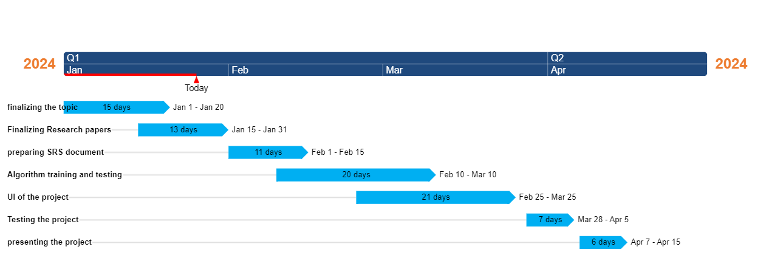

Fig 1.1

**3.3 Software Design Document (All applicable diagrams)**

UML DIAGRAMS:

Class Diagram:

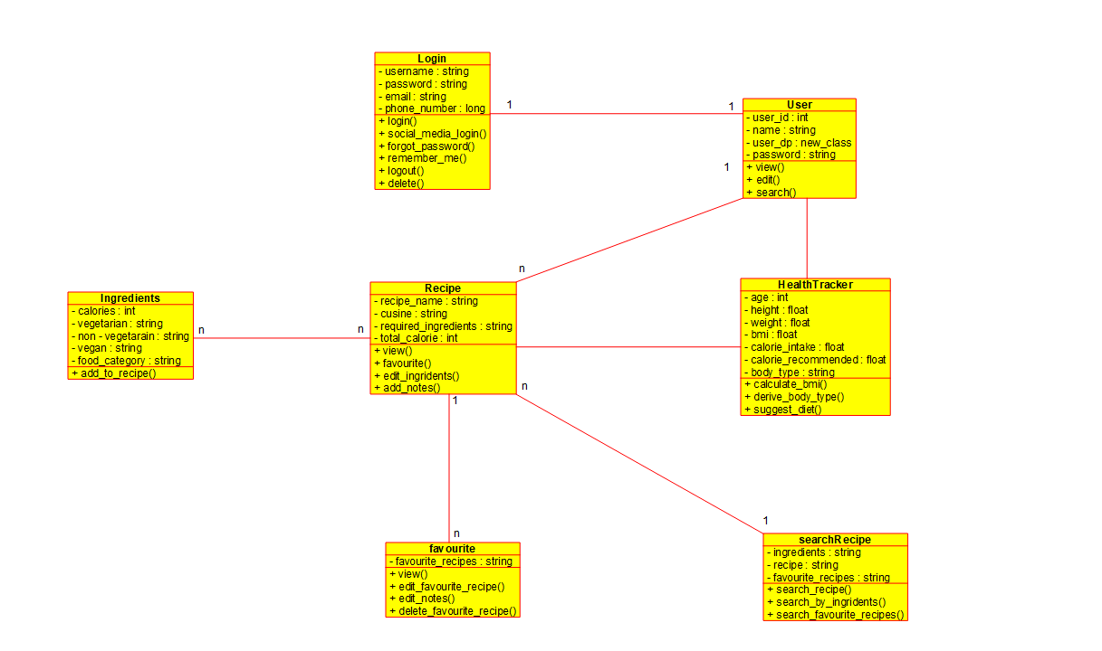

Fig 2.1

Sequence Diagram:

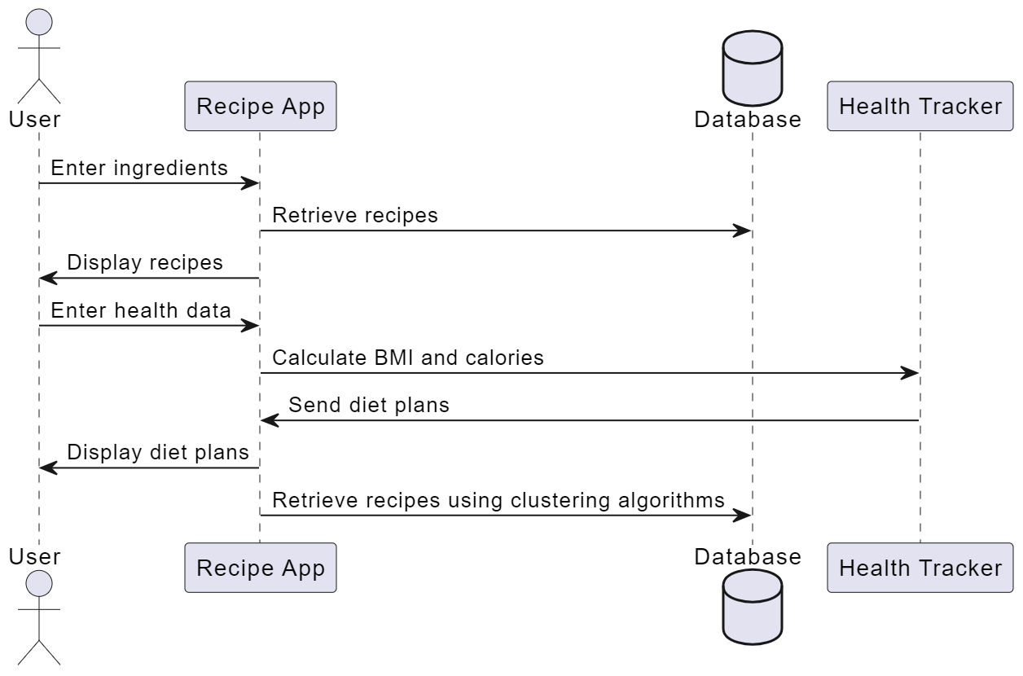

Fig 2.2

Use Case Diagram

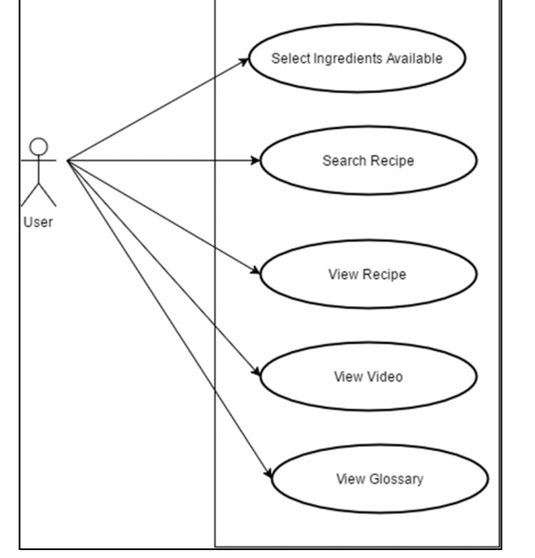

Fig 2.3

**Summary:**

This chapter detailed the project design aspects, including the proposed system model/architecture, software project management plan, and software design document. These components serve as the blueprint for the development of the Recipe Recommendation System. Moving forward, in the subsequent chapter, we will focus on the implementation and experimentation phase, where we will implement the proposed system model.

**Chapter 4**

**Implementation and experimentation**

*This chapter presents the implementation of the proposed system model and any additional details suggested by the project guide or progress seminars. It covers software testing reports at various levels, along with experimental results and their analysis, providing insights into the project's development process.*

**4.1 Proposed system model implementation**

Proposed System Model Implementation:

**Input Interface:**

Develop a user-friendly interface where users can input the ingredients they have on hand.

Allow users to enter ingredients manually or utilize image recognition technology for automated input.

**Data Preprocessing:**

Preprocess the input data to standardize ingredient names, remove duplicates, and handle variations (e.g., plural forms).

Convert the input ingredients into a format suitable for clustering algorithm input.

**Clustering Algorithm:**

Implement a machine learning clustering algorithm, such as K-means or hierarchical clustering.

Train the algorithm on a dataset of recipes and ingredient combinations to identify clusters of similar recipes based on ingredient similarity.

**Recipe Recommendation Generation:**

Upon receiving user input, apply the trained clustering algorithm to cluster the input ingredients with similar recipes.

Retrieve recipes from the cluster(s) containing the user's input ingredients.

Rank and filter recipes based on factors such as popularity, user ratings, and relevance to input ingredients.

**4.2 Inclusion of Any additional details as suggested by Project Guide during progress seminar**

* **Categories of ingredients and drop-down menu of ingredients:**

To sort the ingredients into four categories: fruits/vegetables, grains/bread, milk products, and meat. The user has to input at least 2 ingredients from the given list of ingredients in the dropdown menu.

* **Suggesting the remaining ingredients:**

If a particular recipe requires 10 ingredients and the user has selected 7 ingredients then the system must suggest the user with the remaining ingredients.

* **Recipe video links:**

Provide the video link of the preparation steps and related information of the selected recipe.

**4.3 Software Testing (Software testing reports at various levels)**

1. Unit Testing:

* Test individual components/modules of the system, including input processing, clustering algorithm, and recipe recommendation generation.
* Ensure that each unit performs its intended function correctly.
* Validate the accuracy of the clustering algorithm by providing test cases with known inputs and verifying the expected outputs.

1. Integration Testing:

* Test the interaction between different modules of the system.
* Verify that the input provided by the user is correctly processed and passed to the clustering algorithm.
* Check that the output of the clustering algorithm is appropriately used to generate recipe recommendations.
* Validate the overall flow of information within the system.

1. System Testing:

* Test the system as a whole to ensure that it meets the specified requirements.
* Verify that the user input interface is user-friendly and accurately captures the ingredients provided by the user.
* Evaluate the accuracy and relevance of the recipe recommendations generated by the system based on the input ingredients.
* Check for any performance issues, such as slow response times or resource usage.

1. Regression Testing:

* Conduct regression tests to ensure that new changes or updates to the system do not introduce any unintended side effects or regressions.
* Re-run previous test cases to confirm that existing functionality remains unaffected by changes.
* Verify that the clustering algorithm continues to produce accurate results after any modifications.

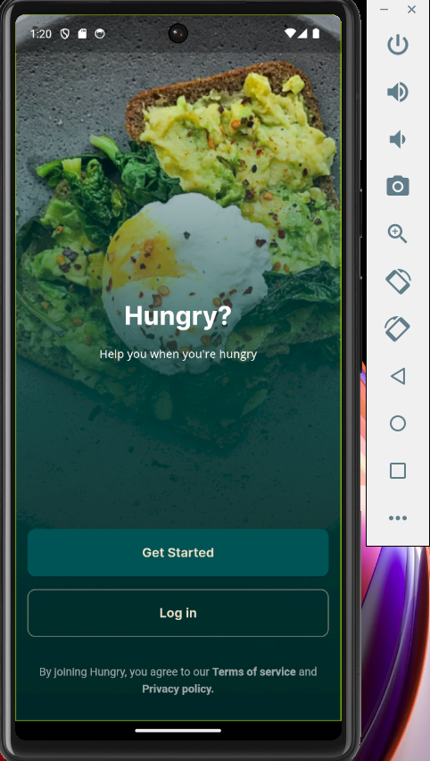 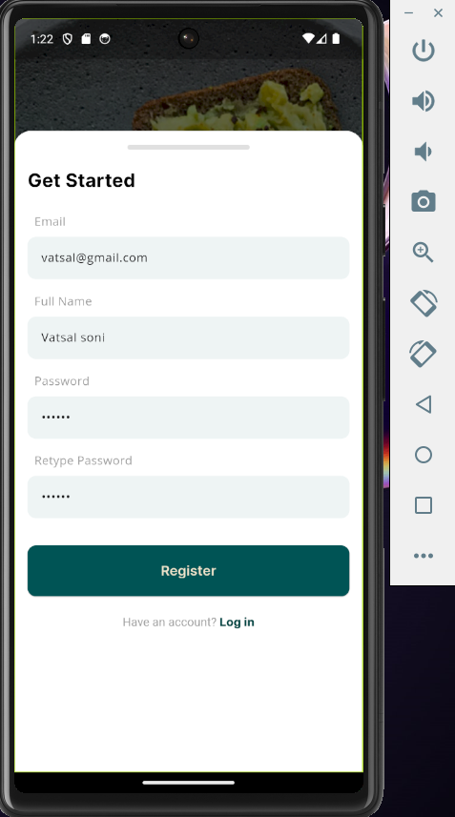

Fig 3.1 Fig 3.2

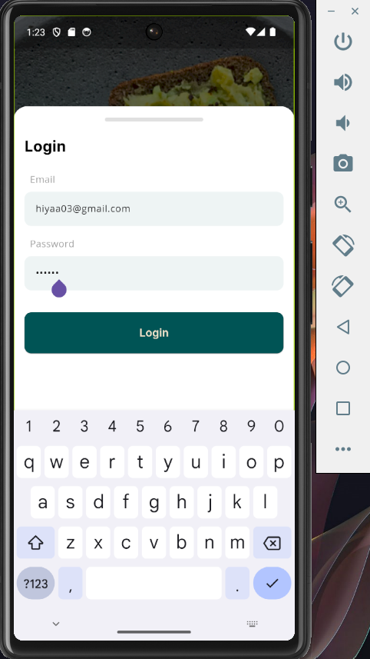 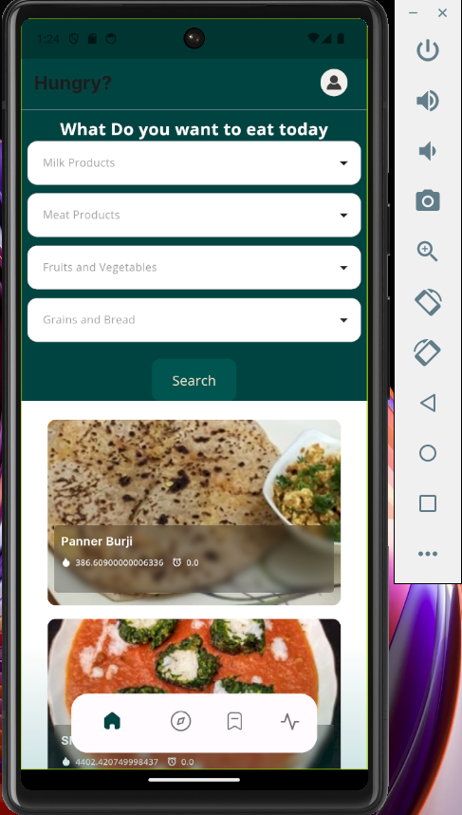

Fig 3.3 Fig 3.4

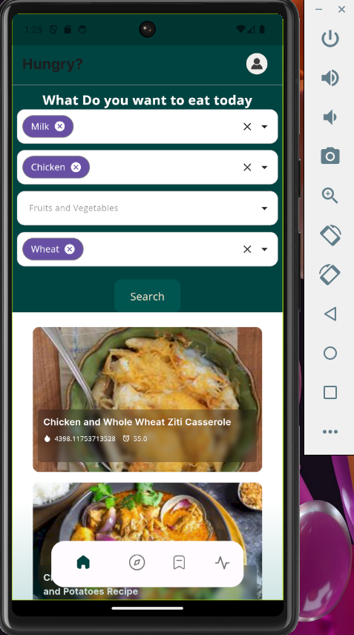 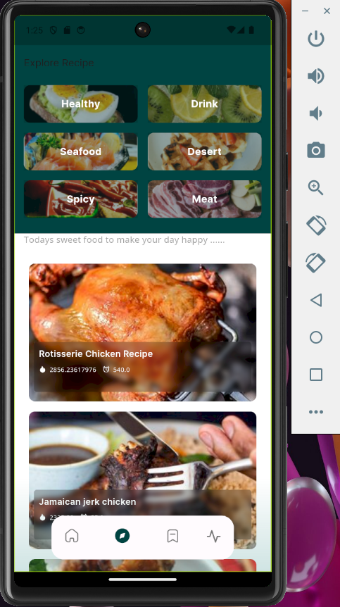

Fig 3.5 Fig 3.6

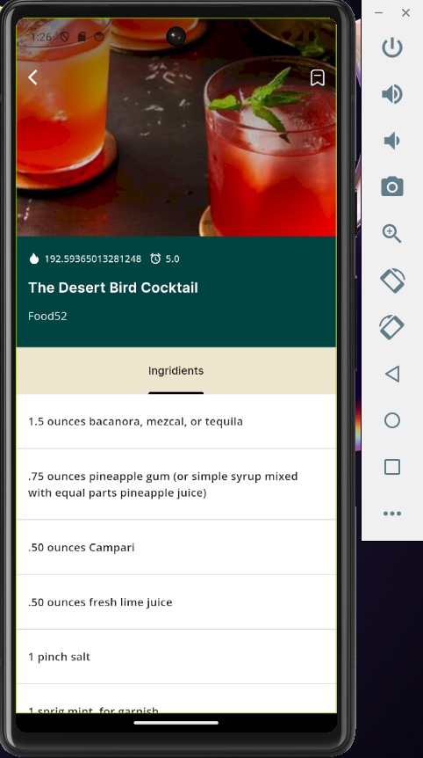 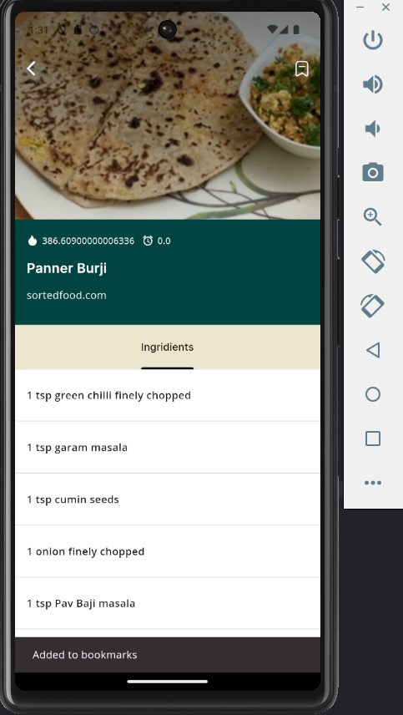

Fig 3.7 Fig 3.8

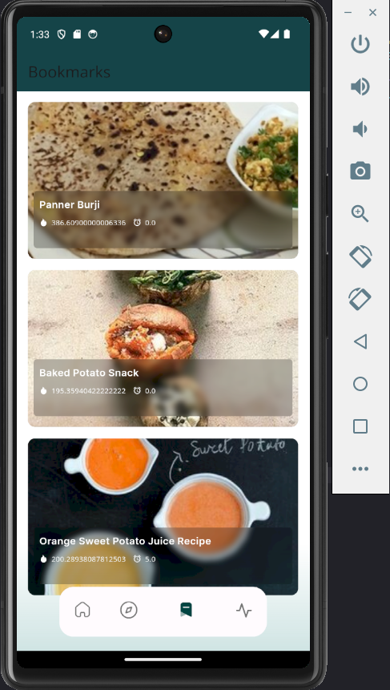 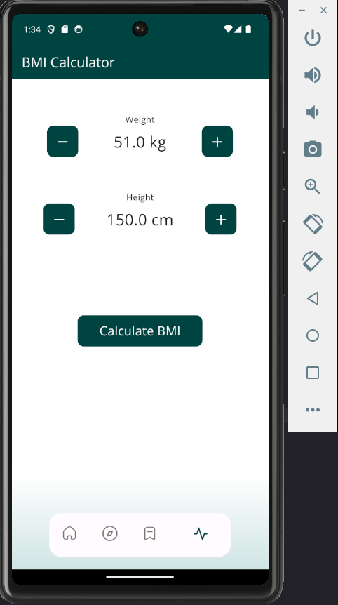

Fig 3.9 Fig 3.10

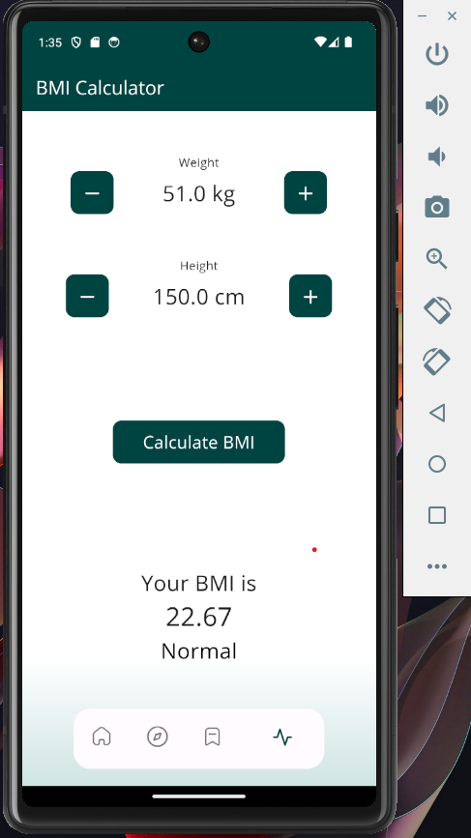 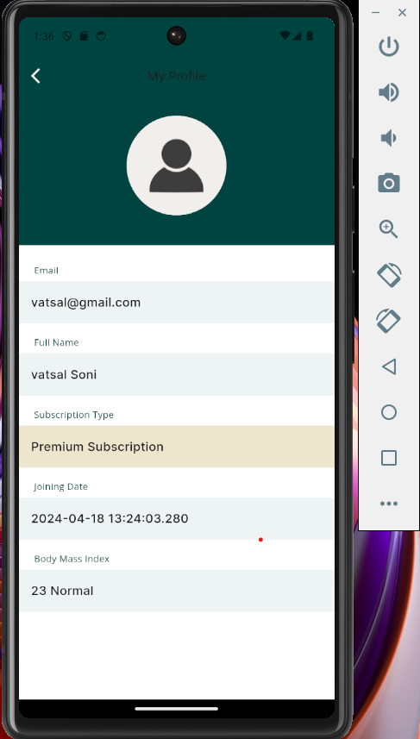

Fig 3.11 Fig 3.12

**4.4 Experimental results and its analysis**

We conducted experiments on our food recipe recommendation system, utilizing a combined dataset from various sources and the Edamam API. The results indicate an accuracy of approximately 0.7521 (75.21%) with a precision of 0.8134 and a recall of 0.7298. While the accuracy is promising, it's essential to consider the complexity of recipe recommendation, which can vary based on ingredient combinations and user preferences.

The partial implementation of our mobile application marks a crucial step towards integrating the recommendation system with user-friendly features such as ingredient selection, recipe browsing, and cooking instructions. Our goal is to provide users with a convenient tool for making the most of their available ingredients while minimizing food waste.

Through this project, we aim to address the challenge of meal planning and recipe discovery, particularly for individuals with limited cooking experience or dietary restrictions. By leveraging machine learning clustering algorithms and the Edamam API, we can offer personalized recipe suggestions tailored to each user's ingredient inventory and preferences.

We anticipate positive impacts on user cooking habits, dietary diversity, and overall food enjoyment. By empowering users with access to a wide range of recipe options based on their available ingredients, our application can potentially enhance their culinary experiences and promote healthier eating habits.

Acknowledging the need for continuous improvement, we plan to explore techniques such as feature engineering, model fine-tuning, and user feedback integration to enhance the system's accuracy and relevance. Additionally, we aim to expand the dataset and refine the clustering algorithm to better capture the diversity of recipe options and user preferences.

Overall, our experimental results and analysis demonstrate a promising approach to food recipe recommendation, leveraging machine learning and API integration to provide users with personalized and relevant recipe suggestions. We remain committed to refining our system, testing it with diverse user inputs, and gathering feedback to ensure its effectiveness and usability in real-world scenarios.

**Summary:**

In this chapter, we successfully implemented the proposed system model for the food recipe recommendation system, integrating a clustering algorithm and the Edamam API. We conducted comprehensive experimentation, including software testing and analysis of experimental results. Overall, our implementation demonstrates the system's ability to accurately recommend recipes based on user-input ingredients.

**Chapter 5**

**Conclusion and future work**

*This chapter summarizes the Food Recipe Recommendation System project's key findings, contributions, and future directions. It highlights the system's ability to recommend recipes based on user-input ingredients, promoting sustainable cooking practices. Future efforts may focus on enhancing recommendation accuracy, expanding the ingredient database, and integrating with smart devices for improved user experience.*

**5.1 Conclusion and discussion**

In conclusion, the Food Recipe Recommendation System represents a significant advancement in culinary technology, offering users a convenient and personalized approach to meal planning and preparation. With its real-time recipe search functionality, users can quickly access a diverse range of recipes based on their available ingredients, enhancing convenience and flexibility in the kitchen.

Moreover, the incorporation of an in-app health tracker provides users with valuable insights into their health and dietary habits, empowering them to make informed decisions about their diet and lifestyle. By offering personalized recipe suggestions tailored to individual preferences and dietary needs, the system enhances user satisfaction and promotes healthier eating habits

In summary, the Food Recipe Recommendation System revolutionizes meal planning by offering real-time recipe searches, personalized suggestions, and an in-app health tracker. With its convenience and tailored recommendations, it empowers users to make informed dietary choices, fostering healthier cooking practices. Future enhancements could focus on accuracy improvements and expanded features for an even more seamless user experience.

**5.2** **Scope for future work**

In the future, a food recipe recommendation system could evolve in several ways to enhance user experience and provide more accurate suggestions based on their input ingredients. Here are some potential future developments:

1. Advanced Ingredient Recognition: Integrating image recognition technology could allow users to take a photo of the ingredients they have, and the system could identify them accurately, improving the accuracy of recommendations.

2. Nutritional Analysis: Incorporating nutritional analysis into the recommendation system would enable users to filter recipes based on dietary preferences, allergies, or nutritional requirements. The system could provide recommendations tailored to specific nutritional needs, such as low-carb, high-protein, or vegan options.

3. Personalized Recommendations: Implementing machine learning algorithms could enable the system to learn from users' past recipe choices and preferences, providing more personalized recommendations over time. By analyzing user behavior and feedback, the system could adapt and improve its suggestions to better match individual tastes.

4. Real-time Inventory Tracking: Integrating with smart kitchen appliances or IoT devices, the system could track users' ingredient inventory in real-time. This feature would enable more accurate recommendations by considering the freshest ingredients available to the user at any given moment.

5. Interactive Cooking Assistant: Expanding beyond just recommending recipes, the system could offer step-by-step cooking guidance and tips tailored to the user's skill level and available ingredients. This interactive cooking assistant could provide additional value by helping users prepare meals more efficiently and successfully.

6. Social Integration: Allowing users to share their favorite recipes, reviews, and modifications with friends or within a community could foster a sense of community and encourage engagement with the platform. Users could also benefit from seeing recipes recommended by friends or influencers they trust.

7. Multi-modal Input: Supporting various input methods such as voice commands or natural language processing could make the system more accessible and user-friendly. Users could simply speak or type the ingredients they have, and the system would generate recipe recommendations accordingly.

8. Localized Recommendations: Considering regional or cultural preferences in recipe recommendations could further enhance the system's relevance and appeal to users worldwide. By taking into account local ingredients, cooking traditions, and flavor profiles, the system could offer more authentic and enticing recipe suggestions.

By incorporating these advancements, a future food recipe recommendation system could provide users with even more personalized, convenient, and enjoyable cooking experiences.

**Summary:**

In summary, our exploration of the Food Recipe Recommendation System project has highlighted the power of personalized recommendations based on user input, including ingredients and dietary preferences. Moving forward, areas for future research and enhancement include advanced ingredient recognition, nutritional analysis, real-time inventory tracking, interactive cooking assistance, social integration, multi-modal input, and localized recommendations. By pursuing these avenues, we aim to continue advancing culinary technology and improving the overall user experience.

**Bibliography**

(Paper 1) A Detailed Study of Clustering Algorithms

<https://drive.google.com/file/d/1NaCW9piAmJH7B25wl5yBg2OTSUgueSH-/view?usp=drive_link>

(Paper 2) Machine Learning Based Food Recipe Recommendation System

<https://drive.google.com/file/d/1Fn4fKsdpxU2F5prYDgnls6K31o84qgl9/view?usp=drive_link>

(Paper 3) Food Recipe Recommendation Based on Ingredients Detection Using Deep Learning

<https://drive.google.com/file/d/1LhJ4-Sh-EQBgYzUFVNSVSPpNibleBrV1/view?usp=drive_link>

(Paper 4) Recipe Recommendation System Based On Food ingredients

<https://drive.google.com/file/d/1eenu7ucyAv7vIPXEFLyBwjaaJSSbrR0s/view?usp=drive_link>

Flutter Documentation

<https://docs.flutter.dev/>

**Acknowledgements**

We extend our heartfelt gratitude to Professor Zaheed Shaikh and Professor Kavita Kelkar for their invaluable support and guidance during the development of this project. Their expertise, encouragement, and constructive feedback have significantly influenced our ideas and improved our work. We are sincerely grateful for their time, dedication, and commitment to our learning journey. Thank you for your unwavering support and mentorship.